INTRODUCTION

**Stationery shop** is a shop of education related item but in this shop all related education items are available. This shop is individual shop by owner Mr. Rohan Wasnik.

In this shop maintain how many type of item buying and selling with computerize recording. It is the only **Stationery shop** in the streets.It mainly carries ball pens, pens, pencils, pencil-boxes, erasers, notebooks, backpacks and other kinds of stationery for different ages of the students.

The main business of the stationery shop is going to sell stationery covering all kinds of pens, pencils, ball pens, rulers, pencil-boxes, notebooks, envelops, etc. It also carries things for albums and letter papers, sharpeners.

It usually has a stock of 18,000 stationery which increases when a semester starts and decreases by the end of school year. The different ball pens with colorful designs and advanced functions, various size of the notebooks, all kinds of smell of erasers always enjoy a high rate.

OBJECTIVES

* **Is legal business**: The Stationery shop is a legal shop, where legal business is done and gives the consumers legal stationeries in the market.
* **Only profit motive**: The main objective of this shop is to earn a lot of profit than any other business and gives a healthy competition to others.
* **Daily maintain record**: The Maintenance of the daily record is done through this software where the operator customizes all record according to its specification and importance and save it in the software.
* **Provide proper material**: Proper maintenance of material provides proper stock in the shop, if the stock details are clear then the consumer’s requirement can fulfill.
* **Ten hour available**: This shop is only available 10 hours in a day.
* No credit available for unknown consumer

Identification Of Need

One must know what the problem is before it can be solved. It helps to find out real problem of the existing system without clear understanding of the problem the further work will be wastage of time and energy. So it is necessary to identify the actual problem. The initial investigation must satisfy the following conditions:

1. What is the real problem?
2. How serious it is?
3. Is it necessary to solve?

The success of the system depends largely on how accurately a problem is defining thoroughly investigation`& properly carried out through the choice of the solution here mostly concern with the user need rather that what he or she wants.

Preliminary Investigation

Preliminary investigation deals with the investigation on the basic of initial stage of the project. In this stage of project development we have required various information related to user.

In this project “STATIONERY SHOP“ we have to collect information from the required shop that what type of features he want to in this software product, for that we have to meet with that particular shop and listed out the needs and requirement of the owner of the petrol pump. While making a meeting with particular required firm we have to maintain a peaceful environment and better communication level which is understood by both parties i.e. analyst and as well as particular firm i.e. STATIONERY SHOP.

Need of New System

New system is been prepared keeping in mind that it deals effectively & more flexibly than the existing system & technology may allow faster processing, more storage and lower costs than ever before.

In today’s modern world, when everything is becoming more and more computerized, one may feel that the task of keeping the records of the patients should also be done automatically using the computer programs. We are just trying out to make an alternative program for its best purpose. The system will allow the users of the software to get the perfect know-how.

The need of new system arises due to the following reasons:

* In Today’s era, for maintaining the records of the patients

had done on the house needs good technical systems. In the systems the registers are used for keeping the record of every patient and all the work which was done manually.

* Accurate Report need transmitted between departments so that proper co-ordination can be maintained between them.

Flaws/Defects in present system

It is necessary to know that what defects are available in the present system or problem occurred in the present system, and see the following things if it then we have to change the system :

1. Is the present system not recommended for work?
2. Is the defect is very serious one?

Project Category

We have selected the project category for this project is Visual basic 6.0 as Front End and MS Access as Back End.

* About Visual Basic 6.0:

Now a days in the field of computers, many languages are being discovered for programming and they are vanishing so quickly. But Visual Basic is the most important language in the world of programming. Visual Basic is not just a programming language, it is an integrated (IDE) in which we can develop, run, test and debug our application. Microsoft Visual Basic offer the quickest and easiest way to create powerful full featured applications. Visual Basic helps you to be more productive by offering appropriate tools for the different aspect of GUI development. You create GUI for your application by simply drawing controls in a graphical way. Visual Basic responds to event that comes to a program from any controls.

Visual Basic comes from the word BASIC. BASIC means:

B: - Beginners

A: - All purpose

S: - Symbolic

I: - Instruction

C: - Code

So, because of as above mention reasons we have used visual Basic 6.0 as Front End tools for this Project i.e. for STATIONERY SHOP.

* About Microsoft Office Access:

When we take Visual basic as front end then we take MS Access as Back End because it gives more user friendly Environment for operators to work with ongoing data transactions.

In the age of computer many software and tools are developed for getting the desired work through the database, database is very important part of any project or a desired software. Without database there no meaning of software or any project in this world. Database is like a soul of the project or software. In access we have given various operations are given through which we can easily perform the various operations of the database like, modifications, deletions, updating, merging the data operation and so on with the help of modify query, delete query, update query, etc.

As mention as above about visual basic & access because of that we have chosen Visual Basic as Front End and Access as Back End.

Software Requirement

When you initiate any Project then there is need of some software requirement. Here we have also need of some software requirement some of them are listed below:

* Windows XP
* Microsoft Visual Studio 6.0
* Microsoft Office

Note:-

It is also mention that all software as mention as above is properly install in your computer, then only your project work properly.

Hardware Requirement

Any physical component of the computer system is known as “Hardware”.

Our project is basically Windows based. We have used many devices of computer system which are as follow:

* Motherboard: 845 Intel original
* RAM: 256 MB
* Processor: 2.0 GHz
* Hard Disk: 40 GB

Data Flow Diagram

Context Diagram

Availability

# Request, Payment

**Product, Detail**

**Request**

**Report**

Customer

**Stationery**

**Shop**

**Product,bill**

**Request**

# Request

Products

Management

**Report**

### First Level DFD

# Request, Payment

**Customer’s Information**

**Customer File**

**Product, Bill**

**1.0**

**Customer Details**

**Shop**

**Product**

**Purchase File**

**Request**

**Stock File**

**Request**

**2.0**

**Stock update**

**Customer’s**

**Purchase File**

**Product, Bill**

**Request, Payment**

**Stock File**

**3.0**

**Sales**

**Customer’s**

**Income File**

**file**

**Product,**

**Sales File**

### Process Logic

**Customer Registration**

# Request, Detail

**Search Details**

**Detail, Report**

**Request**

**Report**

**Stationary Shop**

**Discharge Bill**

**Request**

# Request

# Items Available

**Customer Reports**

**Report**

Data Structure and Tables

Bill Generation (Design view)

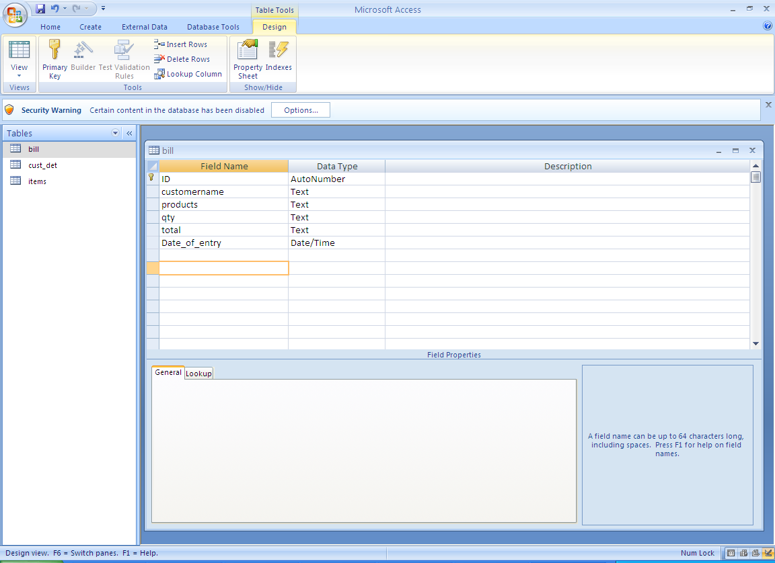

Customer Details (Design View)

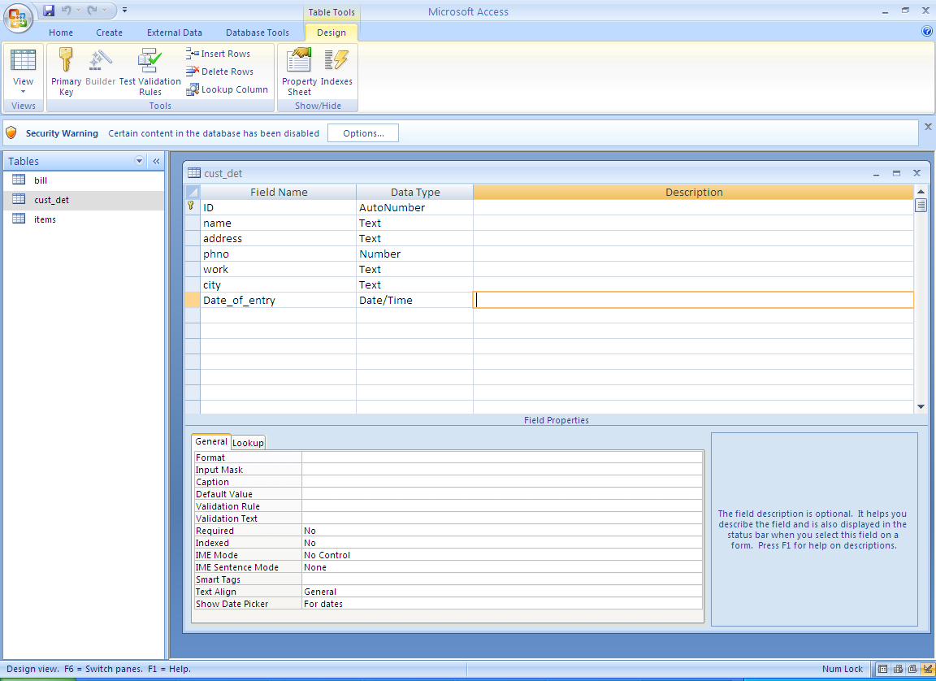

Item Details (Design View)

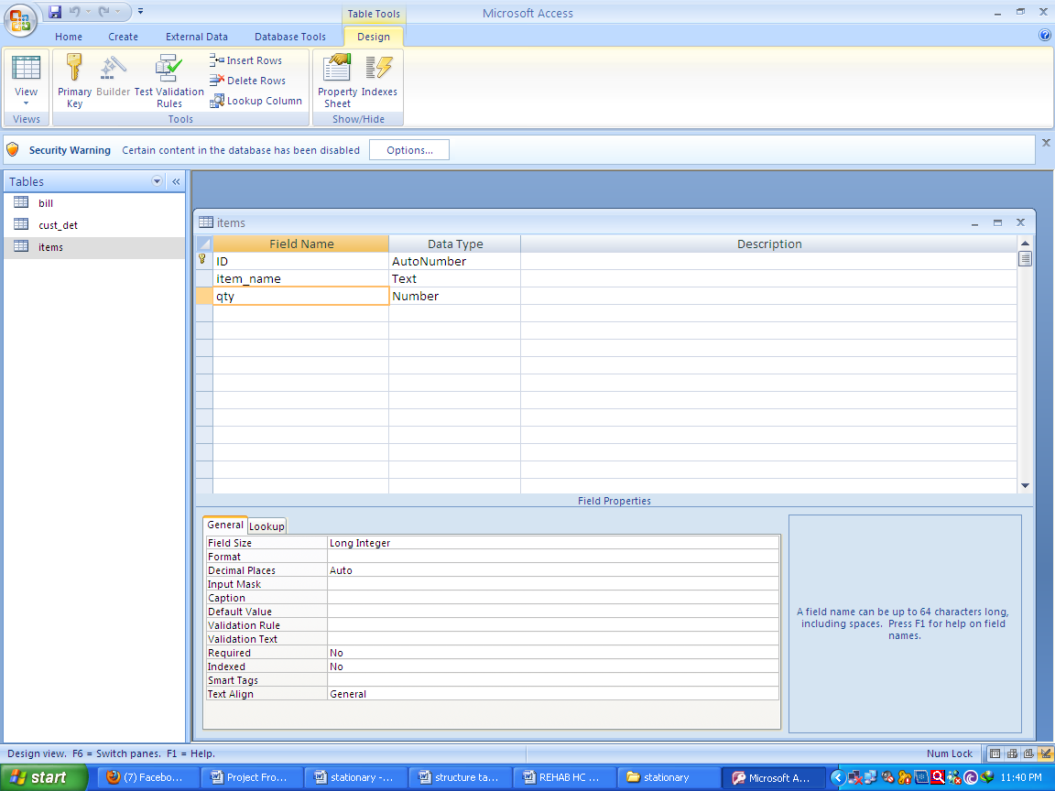

## System Chart

Stationary Shop

**Ch**

**Ch**

**Ch**

**Ch**

**Stationary Supplied**

**Generate Bill**

**Add Item**

**Availability**

Customer Detail

##### C

##### B

##### A

Entity Relationship Diagram

**Customer Detail**

**Generate Bill**

**AddItem**

GO TO CEN-TER

Source Code

**CODING OF MDI FORM**

Private Sub ad_Click()

customer_details.Show

End Sub

Private Sub ai_Click()

addItems.Show

End Sub

Private Sub bd_rpt_Click()

BillsReport.Show

End Sub

Private Sub ca_Click()

checkAvail.Show

End Sub

Private Sub cd_rpt_Click()

cust_det.Show

End Sub

Private Sub exit_Click()

End

End Sub

Private Sub gb_Click()

generateBill.Show

End Sub

Private Sub MDIForm_Load()

End Sub

Private Sub sc_Click()

checkAvail.Show

End Sub

Private Sub vd_Click()

viewBlls.Show

End Sub

**CODING OF ADD ITEMS FORM**

Option Explicit

Public cn As ADODB.Connection

Public rs As ADODB.Recordset

Private Sub Command1_Click()

If Text1.Text = "" Or Text2.Text = "" Then

MsgBox "plz fill the form"

Else

On Error Resume Next

Adodc1.Recordset.AddNew

With Adodc1.Recordset

.Fields(1) = Text1.Text

.Fields(2) = Text2.Text

End With

Adodc1.Recordset.Save

MsgBox "Saved..", vbOKOnly

Adodc1.Recordset.Close

Unload Me

addItems.Show

End If

End Sub

Private Sub Form_Load()

Adodc1.ConnectionString = "Provider=Microsoft.Jet.OLEDB.4.0;Data Source=" & App.Path & "\pop.mdb;Persist Security Info=False"

Adodc1.RecordSource = "select * from items"

Set Text1.DataSource = Adodc1

Set Text2.DataSource = Adodc1

With MS0

.Clear

.Cols = 3

.Rows = 2

.ColWidth(0) = 2000

.ColWidth(1) = 2000

.ColWidth(2) = 2000

.TextMatrix(0, 0) = "Sr NO."

.TextMatrix(0, 1) = "ITEM NAME"

.TextMatrix(0, 2) = "QTY"

End With

MS0.Rows = 1

Text3.Text = ""

Dim cmd As ADODB.Command

Dim cmdtxt As String

'cmdtxt = ""

Me.MousePointer = vbHourglass

Set cn = New ADODB.Connection

cn.ConnectionString = "Provider=Microsoft.Jet.OLEDB.4.0;Data Source=" & App.Path & "\pop.mdb;Persist Security Info=False"

cn.Open

Set rs = New ADODB.Recordset

rs.CursorLocation = adUseClient

rs.CursorType = adOpenStatic

Set cmd = New ADODB.Command

cmd.CommandType = adCmdText

Set cmd.ActiveConnection = cn

cmdtxt = "Select * from items"

cmd.CommandText = cmdtxt

cmd.Prepared = True

Set rs = cmd.Execute

Me.MousePointer = 0

''''''''''''''''''''''''''

Dim R As Integer

R = 1

''''''''''''''''''''''''''Code For entering Data in MSFLEXgrid

Do While Not Me.rs.EOF

MS0.AddItem Me.rs.Fields("id").Value

MS0.Row = R

MS0.Col = 1

MS0.Text = Me.rs.Fields("item_name").Value

MS0.Col = 2

MS0.Text = Me.rs.Fields("qty").Value

R = R + 1

Me.rs.MoveNext

Loop

cn.Close

Text4.Text = R - 1

If Text4.Text = 0 Then

MsgBox "No records found"

End If

End Sub

**CODING OF CHECK AVAILABILITY FORM**

Option Explicit

Public cn As ADODB.Connection

Public rs As ADODB.Recordset

Private Sub Form_Load()

End Sub

Private Sub Text1_Change()

With MS0

.Clear

.Cols = 5

.Rows = 2

.ColWidth(0) = 2000

.ColWidth(1) = 2000

.ColWidth(2) = 2000

.ColWidth(3) = 2000

.ColWidth(4) = 2000

.TextMatrix(0, 0) = "Sr NO."

.TextMatrix(0, 1) = "NAME"

.TextMatrix(0, 2) = "Address"

.TextMatrix(0, 3) = "Phone no."

.TextMatrix(0, 4) = "City"

End With

MS0.Rows = 1

Text3.Text = ""

Dim cmd As ADODB.Command

Dim cmdtxt As String

'cmdtxt = ""

Me.MousePointer = vbHourglass

Set cn = New ADODB.Connection

cn.ConnectionString = "Provider=Microsoft.Jet.OLEDB.4.0;Data Source=" & App.Path & "\pop.mdb;Persist Security Info=False"

cn.Open

Set rs = New ADODB.Recordset

rs.CursorLocation = adUseClient

rs.CursorType = adOpenStatic

Set cmd = New ADODB.Command

cmd.CommandType = adCmdText

Set cmd.ActiveConnection = cn

cmdtxt = "Select * from cust_det where name like '%" & Text1.Text & "%'"

cmd.CommandText = cmdtxt

cmd.Prepared = True

Set rs = cmd.Execute

Me.MousePointer = 0

''''''''''''''''''''''''''

Dim R As Integer

R = 1

''''''''''''''''''''''''''Code For entering Data in MSFLEXgrid

Do While Not Me.rs.EOF

MS0.AddItem Me.rs.Fields("ID").Value

MS0.Row = R

MS0.Col = 1

MS0.Text = Me.rs.Fields("name").Value

MS0.Col = 2

MS0.Text = Me.rs.Fields("address").Value

MS0.Col = 3

MS0.Text = Me.rs.Fields("phno").Value

MS0.Col = 4

MS0.Text = Me.rs.Fields("city").Value

R = R + 1

Me.rs.MoveNext

Loop

cn.Close

Text4.Text = R - 1

If Text4.Text = 0 Then

MsgBox "No records found"

End If

End Sub

**CODING OF CUSTOMER DETAILS FORM**

Private Sub Command1_Click()

If Text1.Text = "" Or Text2.Text = "" Or Text3.Text = "" Or Text4.Text = "" Or RichTextBox1 = "" Then

MsgBox "plz fill the form"

Else

On Error Resume Next

Adodc1.Recordset.AddNew

With Adodc1.Recordset

.Fields(1) = Text1.Text

.Fields(2) = RichTextBox1.Text

.Fields(3) = Text2.Text

.Fields(4) = Text3.Text

.Fields(5) = Text4.Text

End With

Adodc1.Recordset.Save

MsgBox "Saved..", vbOKOnly

Adodc1.Recordset.Close

End If

End Sub

Private Sub Command2_Click()

Unload Me

End Sub

Private Sub Form_Load()

Adodc1.ConnectionString = "Provider=Microsoft.Jet.OLEDB.4.0;Data Source=" & App.Path & "\pop.mdb;Persist Security Info=False"

Adodc1.RecordSource = "select * from cust_det"

Set Text1.DataSource = Adodc1

Set RichTextBox1.DataSource = Adodc1

Set Text2.DataSource = Adodc1

Set Text3.DataSource = Adodc1

Set Text4.DataSource = Adodc1

End Sub

**CODING OF GENERATE BILL FORM**

Private Sub Command1_Click()

On Error Resume Next

Adodc3.Recordset.AddNew

With Adodc3.Recordset

.Fields(1) = Combo2.Text

.Fields(2) = Text4.Text

.Fields(3) = Text2.Text

End With

Adodc3.Recordset.Save

Me.PrintForm

MsgBox "Saved..", vbOKOnly

Adodc3.Recordset.Close

End Sub

Private Sub Command2_Click()

Dim x As Long

Dim inx As Integer 'counter

List1.AddItem Combo1.Text

List2.AddItem Val(Text3.Text) * Val(Text1.Text)

Text4.Text = Text4.Text & Me.Combo1.Text & ","

For inx = 0 To List2.ListCount - 1

x = x + CInt(List2.List(inx))

Next

Text2.Text = x

End Sub

Private Sub Form_Load()

Adodc1.ConnectionString = "Provider=Microsoft.Jet.OLEDB.4.0;Data Source=" & App.Path & "\pop.mdb;Persist Security Info=False"

Adodc1.RecordSource = "select item_name from items"

Adodc1.Refresh

Do While Not Adodc1.Recordset.EOF

Combo1.AddItem Adodc1.Recordset.Fields("item_name").Value

Adodc1.Recordset.MoveNext

Loop

Adodc1.Refresh

Adodc2.ConnectionString = "Provider=Microsoft.Jet.OLEDB.4.0;Data Source=" & App.Path & "\pop.mdb;Persist Security Info=False"

Adodc2.RecordSource = "select name from cust_det"

Adodc2.Refresh

Do While Not Adodc2.Recordset.EOF

Combo2.AddItem Adodc2.Recordset.Fields("name").Value

Adodc2.Recordset.MoveNext

Loop

Adodc2.Refresh

Adodc3.ConnectionString = "Provider=Microsoft.Jet.OLEDB.4.0;Data Source=" & App.Path & "\pop.mdb;Persist Security Info=False"

Adodc3.RecordSource = "select * from bill"

Set Combo2.DataSource = Adodc3

Set Text2.DataSource = Adodc3

Set Text4.DataSource = Adodc3

End Sub

**CODING OF LOGIN FORM**

Private Sub Command1_Click()

If Text1.Text = "admin" And Text2.Text = "admin" Then

main.Show

Unload Me

Else

MsgBox "Invalid User name or Password... ", vbInformation

End If

End Sub

Private Sub Command2_Click()

End

End Sub

Private Sub Form_Load()

End Sub

**CODING OF SPLASH SCREEN**

Private Sub Timer1_Timer()

Unload Me

login.Show

End Sub

**CODING OF VIEW BILLS**

Public cn As ADODB.Connection

Public rs As ADODB.Recordset

Private Sub Form_Load()

Adodc1.ConnectionString = "Provider=Microsoft.Jet.OLEDB.4.0;Data Source=" & App.Path & "\pop.mdb;Persist Security Info=False"

Adodc1.RecordSource = "select * from bill"

Set Text1.DataSource = Adodc1

Set Text2.DataSource = Adodc1

With MS0

.Clear

.Cols = 4

.Rows = 2

.ColWidth(0) = 2000

.ColWidth(1) = 2000

.ColWidth(2) = 2000

.ColWidth(3) = 2000

.TextMatrix(0, 0) = "Sr NO."

.TextMatrix(0, 1) = "Customer Name"

.TextMatrix(0, 2) = "Products"

.TextMatrix(0, 3) = "Total"

End With

MS0.Rows = 1

Text3.Text = ""

Dim cmd As ADODB.Command

Dim cmdtxt As String

'cmdtxt = ""

Me.MousePointer = vbHourglass

Set cn = New ADODB.Connection

cn.ConnectionString = "Provider=Microsoft.Jet.OLEDB.4.0;Data Source=" & App.Path & "\pop.mdb;Persist Security Info=False"

cn.Open

Set rs = New ADODB.Recordset

rs.CursorLocation = adUseClient

rs.CursorType = adOpenStatic

Set cmd = New ADODB.Command

cmd.CommandType = adCmdText

Set cmd.ActiveConnection = cn

cmdtxt = "Select * from bill"

cmd.CommandText = cmdtxt

cmd.Prepared = True

Set rs = cmd.Execute

Me.MousePointer = 0

''''''''''''''''''''''''''

Dim R As Integer

R = 1

''''''''''''''''''''''''''Code For entering Data in MSFLEXgrid

Do While Not Me.rs.EOF

MS0.AddItem Me.rs.Fields("id").Value

MS0.Row = R

MS0.Col = 1

MS0.Text = Me.rs.Fields("customername").Value

MS0.Col = 2

MS0.Text = Me.rs.Fields("products").Value

MS0.Col = 3

MS0.Text = Me.rs.Fields("total").Value

R = R + 1

Me.rs.MoveNext

Loop

cn.Close

Text4.Text = R - 1

If Text4.Text = 0 Then

MsgBox "No records found"

End If

End Sub

Input Screen

**SPLASH SCREEN**



**LOGIN FORM**

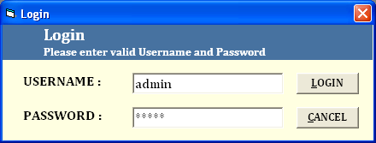

**MDI FORM**

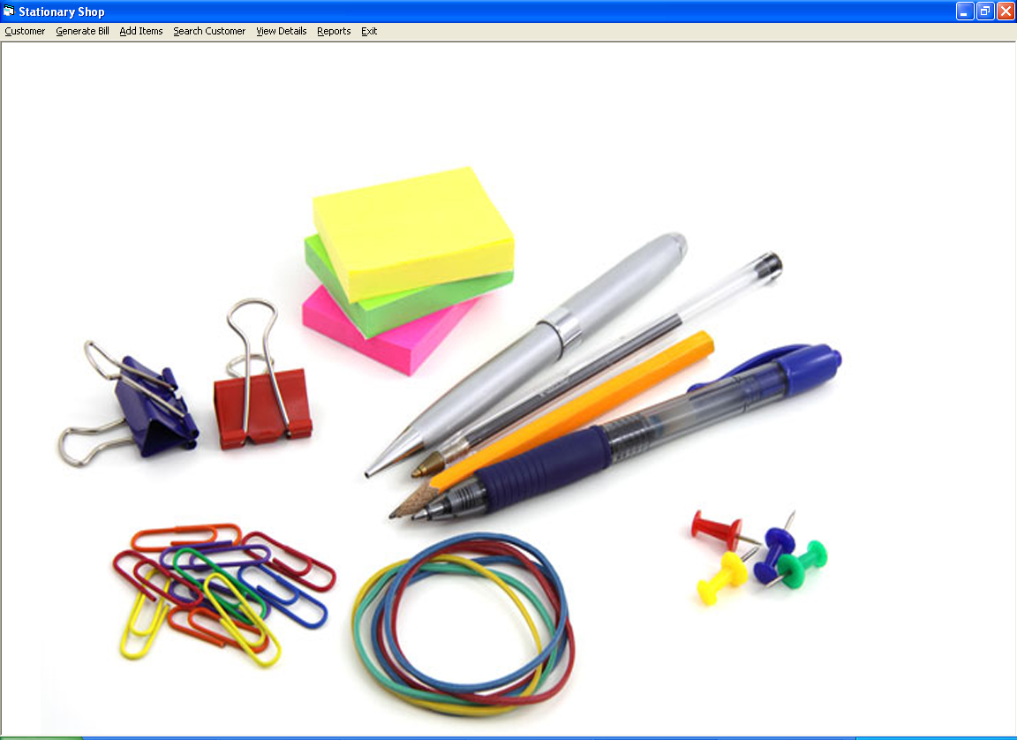

**CUSTOMER DETAILS FORM**

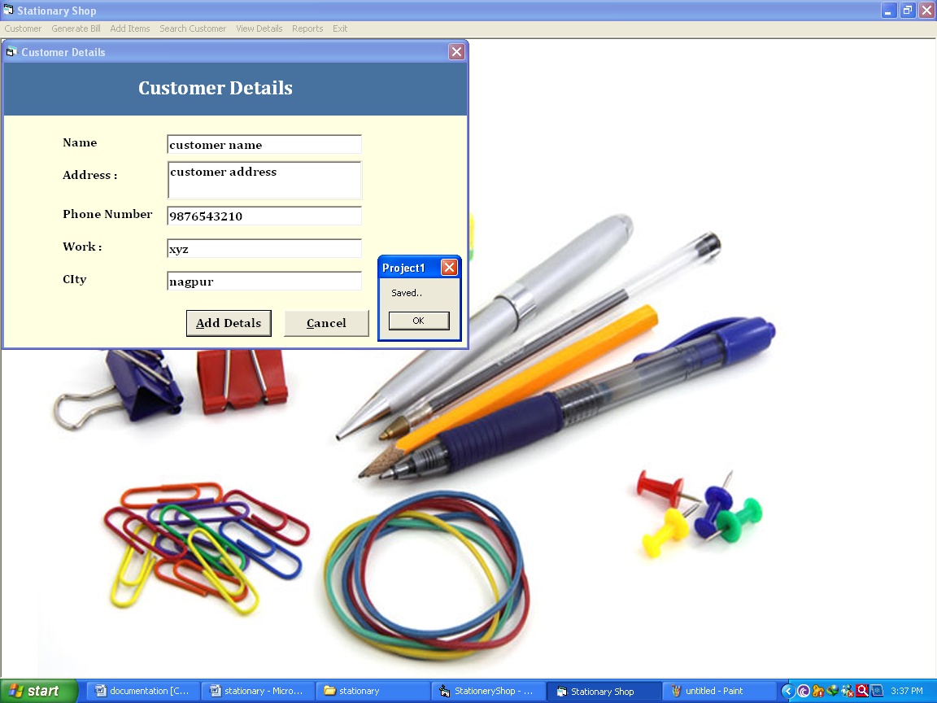

**ADD ITEMS FORM**

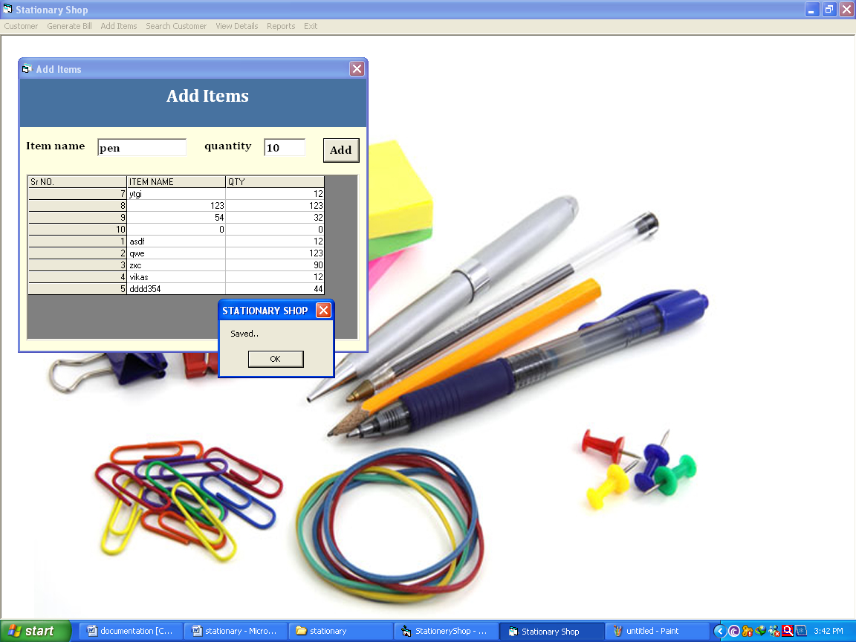

**SEARCH CUSTOMER FORM**

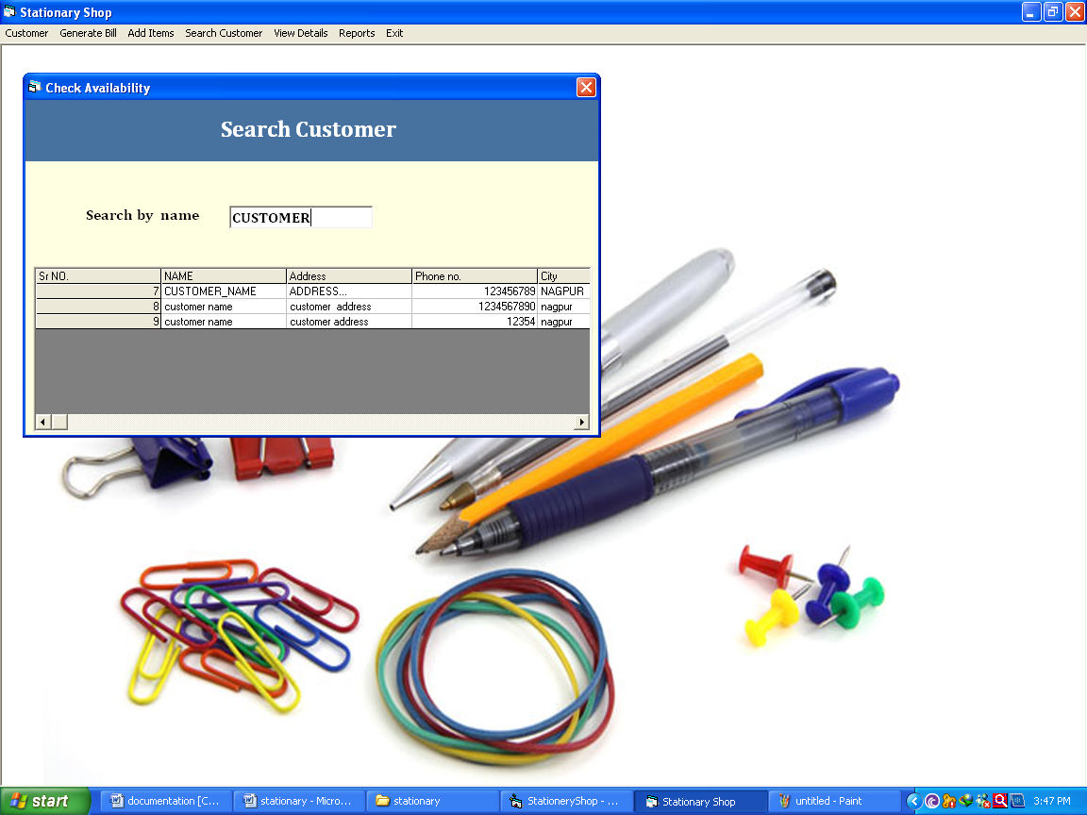

**Generate Bill**

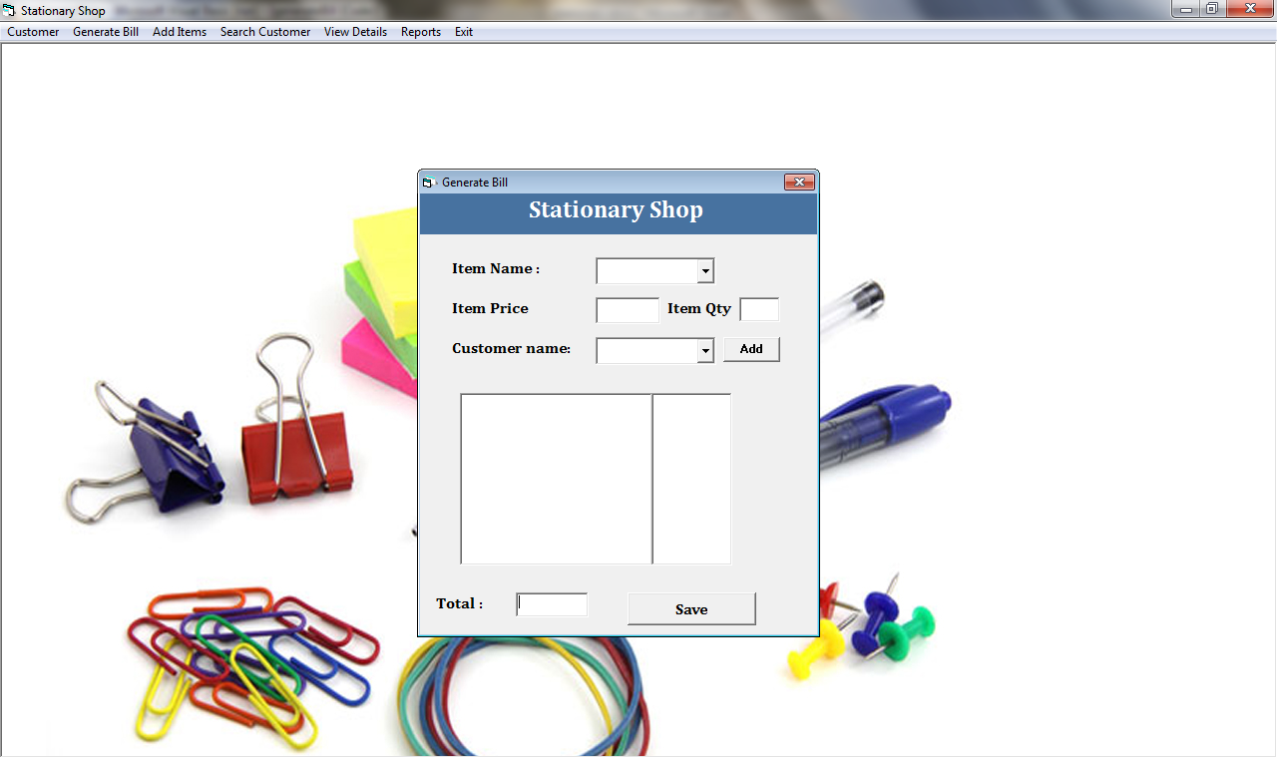

**REPORT CUSTOMER DETAILS**

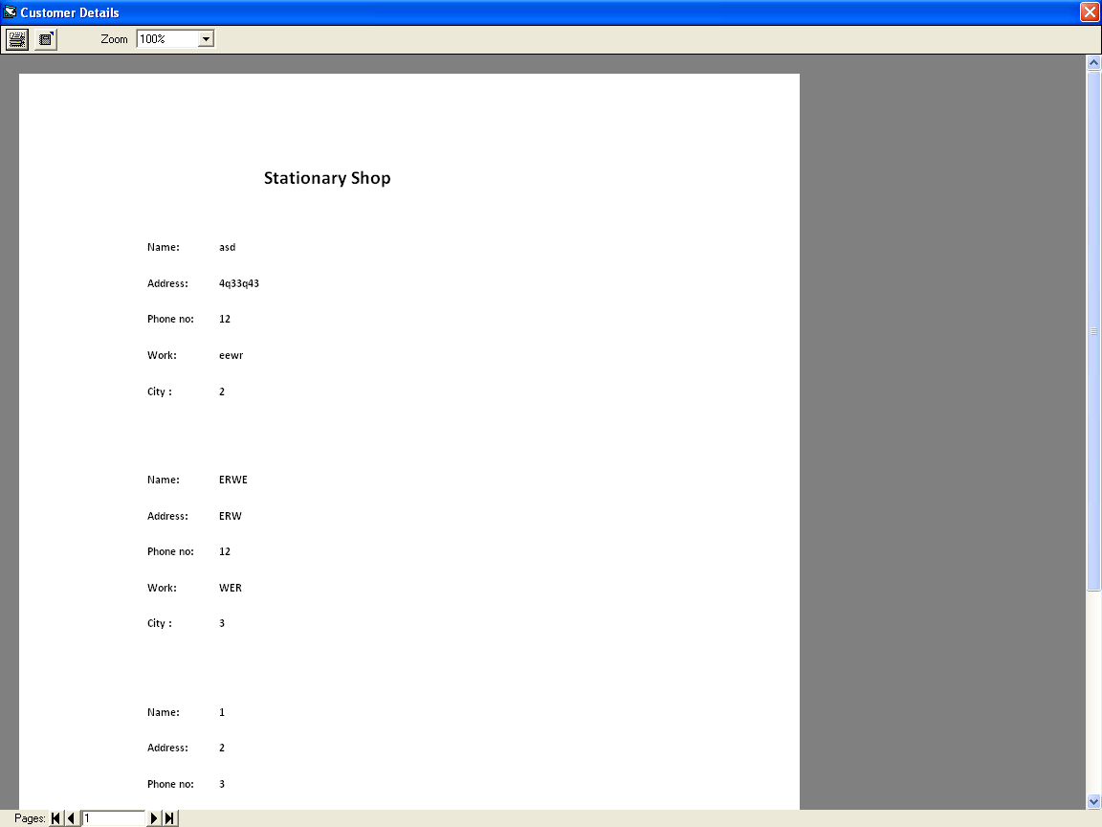

Validation Check

Validity of the data to be entered is an important thing in the project execution. To make the program run successfully all the data that is entered need to be valid so that the user doesn’t get error messages very often. Care need to be taken so that the processes also run without any error. The user should know that which data is to be entered in the text boxes and ought not to be entered. Care should be taken, so that text is not entered in the places where numbers ought to be entered. As this project has made the use of MS-ACCESS, data is to stored in the form of tables where there is a unique key in each field that distinguishes it from another. The user should know such field so that the data is not repeated and the errors are minimized. Another validation check is that proper data needs to be inputted so that the user can get proper output.

1. In project there is strict check for the entry of each field

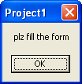

Implementation

Implementation is activity considered as conversion of old system into new system. The term system implementation is defined as the conversion of design and coded system into the actual operation.

In this new system gradually replaces the old system with the new one. Part by part the old system phased out and new system Part by part phased in the result produced by each part of new system is compared against the result of new system, errors are found out and removed once the confidence is develop in a particular part of the new system, that part of the new system is phased in and corresponding part of the old system is phased out.

This method is continuing for each and every part of the new system. The new system is slowly phased in with the old new system and slowly phased out.

### Evaluation

The system approach to recognized that whether the implementation solution is failed to solved the problem for which it was develop i.e. it means whether the implementation need, which it’s objectives or not. If not then the system approaches will back to first step to find the other solution.

This element measures the output against a standard in same form that includes communication and control. After the output is compared against performance standard changes can result in the input or processing and consequently the output, input or processing and consequently the output.

Evaluations are as follows: -

1. The programming language and its feasibility to the application.
2. Ease of installation and training.
3. Extent of enhancement to be made prior to installation.
4. Emergency computer backup available.
5. Programming and installation service provided during conversion.

Adequacy and cost of hardware maintenance

### Maintenance

Maintenance is the enigma of the system development analyst’s and programmer’s spent far more time on maintaining the program than any do writing them.

1. Maintenance over the wide range of activities, including correcting coding and design errors updating documentation rest data and updating user support.
2. Software can be stored to it’s original position by software maintenance
3. Maintenance, which is also referred to as software maintenance, means adding, modifying or developing the code to support changes in the specification.
4. The software developed will need proper monitoring so that any or

unexpected result does not lead to the system crash when the system will be implemented there may be condition which might have been overlooked by the user during testing. For the system to run efficiently weekly evaluation of result set will be done and the user will be consulted for the system performance.

If there is any rectification or enhancement posted by the user, the software will be modified and the desired modules if added will be implemented.

Security Measures

Security of the project needs to be the top most agenda in the minds of the programmer do that the system is saved from the unidentified sources. But our project on "**Stationary Shop**" is a general purpose software, so we can't restrict it to limited user only. Keeping this in mind about the wide applicability of our project in various fields we allow an unrestricted access to all the user. But we as a programmer has provided the primary level of security with the facility of user password so that any unauthorized changes do not take place in the project. We have just provided it as a measure of safety on our part. This provision is been made so that no other user can access the system data.

And a specific time period has been programmed for the security of the system

Future Scope Of The Project

In order to get rid of the shortcomings in the developed system, future modification with regard to the program and management requirement can be made.

To increase the efficiency & functionality of the developed system, the earlier discussed drawbacks are to be eradicated by including relevant programmed module.

The system can be modified to include interactive reports, which would have been used by the user. The interactive report which would return the count of copies of the same title.

Conclusion

This project deals with sales, their details & stock of **“Stationary Shop”**. The modules contain menu driven program though which we can store data regarding salse, stock & profit of the petrol pump. We can even modify the sales, stock & profit if the entry has wrongly been made through human error.

Every menu shows the choices, which are available to be used at the prompt. It also allows having report of purchase , sales, stock and staff.

This system is better than to manual system and has implemented as many.

Limitations

The developed application though satisfies the desired objective but still has few limitations, which one cannot ignore. These limitations could have been eliminated, but due to time constraint and the restricted scope of this project still persists. The limitations of this application are discussed as under:

* We must take notice that this system deals with only stationary products
* Cannot run on internet.

Bibliography

Books Author

* Mastering in Visual Basic 6.0 Evangelos Pettoutses
* Complete V.B. R.T.Richard
* VB Source Code Library Brain Shen EA,AL
* Guide to MS-Access C.Townsend
* MS-Office 2000 G.Corten